**WHAT IS EC2 ?**

ELASTIC COMPUTE CLOUD IS A WEBSERVICE THAT PROVIDES SECURITY AND RESIZABLE COMPUTE CAPACITY IN THE CLOUD WHICH IS DESIGNED TO USED BY DEVOLEPERS EASIER

**STEPS TO CREATE EC2 INSTANCE**

1. **AMI** - AMAZON MACHINE IMAGE CONTAINS THE SOFTWARE CONFIGURATION(OS,APP SERVERS AND APPS)

# EACH AMI ID IS DIFFERENT TO ONE REGION TO ANOTHER REGION

# WE HAVE TO USE ONLY FREE TEIR AMI'S

2. **INSTANCE TYPE** - HERE WE NEED TO SELECET INSTANCE TYPE FOR FREE TEIR WE CAN USE ONLY

T2 MICRO (1 CPU AND 1 GB) AND T2 NANO (1 CPU AND 0.5 GB)

# TOTAL INSTANCE FAMILES 64 AVALIABLE

3. **CONFIGURE INSTANCE** - HERE YOU NEED TO CONFIGURE ALL YOUR INSTANCE DETAILS LIKE

NO.OF INSTANCES , SUBNETS ,VPC , IAM ROLE , TENANCY ALL OTHER STUFF

4. **ADD STORAGE** - HERE YOU CAN ADD YOUR DATA THAT IS ELASTIC BLOCK STORAGE WHICH IS UPTO 8 GB FOR FREE AND EXTEND UPTO 30GB

5. **ADD TAGS** - YOU CAN HAVE NAME TAGS HERE

6. **SECURITY GROUPS** - IT ACTS AS FIREWALL AND PROVIDE SECURITY TO STOP UNWANTED ACESS

# THESE ARE REGION AND NETWORK SPECIFIC

# INBOUND AND OUTBOUND RULES

# Provides security at the protocol and port level access

# it acts as a firewall and deals with the traffic(HTTP & HTTPS)

# S.G in one region can't be seen on another region

# Multiple S.G's can be attached to one EC2 instance

7. **REVIEW** - YOU CAN CHECK ALL THE DETAILS THAT YOU HAVE GIVEN TO MAKE EC2 INSTANCE

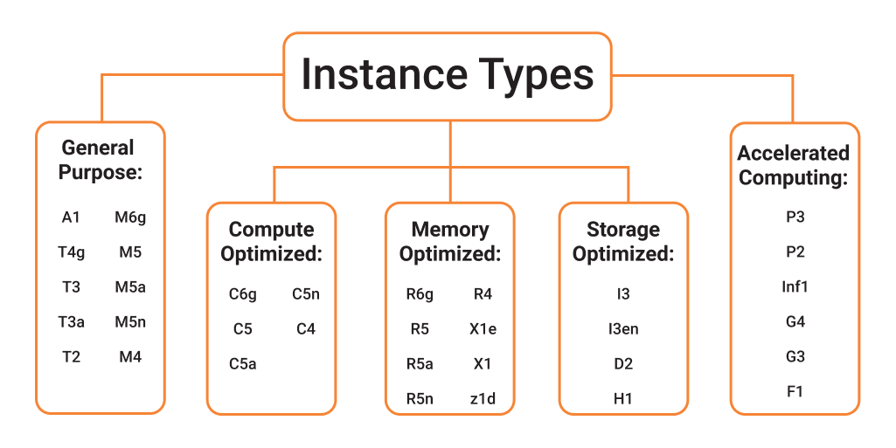

Q . What are the types of virtulization do we have on AWS platform ?

A . HVM (under AMI) & Para virtual (Select Community AMI'S YOU can see there) and also Para virtualization on HVM

Virtualization means ablility to run os on VM without any modifications

Q . What are the different types of EC2 instances based on their costs?

A . The three types of EC2 instances are:

On-demand Instance :

It is cheap for a short time but not when taken for the long term

Spot Instance :

It is less expensive than the on-demand instance and can be bought through bidding.

Reserved Instance :

If you are planning to use an instance for a year or more, then this is the right one for you.

Q . What are the type of root device ?

A . EBS (under AMI) & Instance Store (Select Community AMI'S YOU can see there)

Q . What are the type of EBS volumes and the use cases ?

A . Generally they are 3 types (General purpose SSD , Provisioned IOPS SSD & Magnetic)

There will be another type if you select EBS (Cold HDD & Throughput optimized HDD)

Cold HDD : There will be a master and slave configure Whenever we need to configure slave and read operation is high than write we can use cold HDD

Throughput : If you need overall Throughput you can opt this

Q . What are the differences between t.2 micro and t.3 micro ?

A . For t2.micro(1 cpu & 1 Gb memory) For t3.micro(2 cpu's & 1 Gb memory)

Q . Why do we match IAM role with EC2 machine while creating it ?

A . Only IAM user can have access to do anything if you are normal user you are not able to perform all activities but if you have IAM role you can do anything

Q . What is the Advantage of IAM role with EC2 ?

A . If we have 10 users they are working as admin if you configure your EC2 with a key and multiple users have access for that so if one user tries to copy another user key so in that case it will be a problem We need not to configure individual user key ID

Q . What are the usages of tags with EC2/AWS resource ?

A . AWS allows customers to assign Metadata to their AWS resources in form of tags . Each tag is a simple label consisting of customer-defined key and an optional value that can make it easier to manage , search for and filter resources

Q . What is T2/T3 unlimited options ?

A . AWS will allocate some credits with our account for T2 and T3 type of machines If the machine will perform slowly so CPU Credit usage & CPU Credit Balance can be enabled but we need to pay extra

Q . What are the type of Hypervisors in AWS ?

A . For t2.micro XEN & t3.micro NITRO (very fast and cheaper)

Q . How can we recover lost EC2 ssh key ?

A . The possible ways are

# If you are root user or have sudo access user you can update the key

# Shutdown the machine and mount the root volume of this machine to another machine and update ssh key

Q . How to check shared AMI'S ?

A . Go to ami you can see there what all the public and private images you have shared